Autocorrelation

Reasons of Autocorrelation Consequences Symptoms and Statistical Tests Remedies Possible Consequences
Plotting Current Residual Against Lagged Residual
Order of Autocorrelation

Specification Error
Symptoms
Plotting Current Residual Against Time

Data Manipulation
Trend/Inertia
If autocorrelation coefficient is not different from one
Change in Model

Cobweb Phenomena
Computation and Testing of Autocorrelation Coefficient
Missing Intercept

Autocorrelation
Runs Test
Non-stationarity
First-difference Method
Stationarity of Variables

Statistical Tests
Remedial Measures
Data Transformation
Durbin-Watson d Test

Less Severe Multicollinearity

Durbin’s h Test
If autocorrelation coefficient is different from one
Breusch-Godfrey Test
Appropriate Measure of Rho

Inefficient OLS Estimators

Consistent OLS Estimators

Unbiased OLS Estimators
Generalized Difference Method
Change in Model

Misleading Conclusions on Statistical Tests

Right Order of Autocorrelation

- About Autocorrelation:
- In the classical linear regression model, it is assumed that there is no autocorrelation in the random disturbance term, i.e., 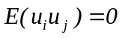for all 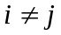
- The problem of autocorrelation occurs when this assumption is violated, i.e.,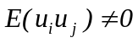, (This implies that the random disturbance term is not independent across the observations
- Autocorrelation is more likely to occur in case of time-series data as the observations here follow a natural ordering
- The other possible reasons for autocorrelation include cobweb phenomena, data transformation, data manipulation, non-stationarity in the random disturbance term, specification errors, business cycle phenomena, etc.

- Consequences of Autocorrelation:
In the presence of autocorrelation, OLS estimators are:
- Still unbiased, consistent and asymptotically normally distributed
- However, they are no longer efficient
- Hence, the usual t, F and χ² tests cannot be legitimately applied to test the hypotheses
- Testing for Autocorrelation
Model: 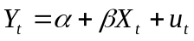
- Graphical Plots
- Plotting 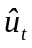 against time (t)
Steps to be followed:
- Estimate the model
- Estimate from the estimated model
- Plotting against time and understanding the patterns of the line
- If the line shows changes in sign of the residual () only for a few number of times, we suspect positive autocorrelation
- If the line shows changes in sign of the residual () too many times, we suspect negative autocorrelation
- If the line shows changes in sign of the residual () for moderate number of times, we expect no autocorrelation problem
Do we need standardization of the residuals for the plotting against time (t)?
- Plotting against 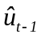
Steps to be followed:
- Estimate the model
- Estimate from the estimated model
- Arrange the second to the last observations as and the first to the second last observations as (Hence, we have n-1 observations now)
- Plotting against and understanding the patterns of the scatter plot
- If the scatter plot shows increasing (decreasing) patterns, we suspect positive(negative) autocorrelation
- If the scatter plot does not show any pattern, we expect no autocorrelation problem
- Statistical Tests:
- Runs Test (Corresponding to Plotting against time)
- A run is an uninterrupted sequence of a specific sign of the residual, and the number of elements in a run represents its length
- While only a few runs indicate positive autocorrelation, too many runs implies negative autocorrelation
U_{t}-hat U_{t}-hat U_{t}-hat

Time Time Time
Positive Autocorrelation Negative Autocorrelation No Autocorrelation

- Moderate or reasonable number of runs indicates no autocorrelation
- Null Hypothesis - H₀: Residuals are independent (no autocorrelation)
- Rejection of the null hypothesis indicates presence of autocorrelation

Steps to be followed:
- Estimate the model
- Estimate and consider the sequence of a specific sign of the residual to count the number of runs
- Construct the following 95 percent confidence interval (the confidence limit may vary)
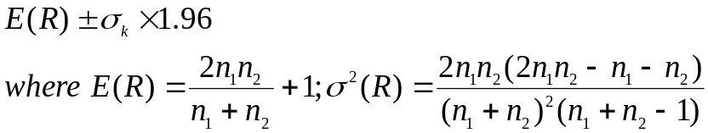

n = total number of observations; n₁= number of positive residuals; n₂ = number of negative residuals; R = number of runs

- The number of runs (R) follows asymptotically normal distribution when n₁ > 10 and n₂ > 10
- If the actual number of runs falls outside the confidence interval, the null hypothesis is rejected indicating presence of autocorrelation

- Decision Rules in Runs Test:

  - If the observed number of runs is within the confidence interval, there is no problem of autocorrelation
  - If the observed number of runs is less than the lower limit (i.e., too few runs) , there is positive autocorrelation
  - If the observed number of runs is greater than the upper limit (i.e., too many runs), there is negative autocorrelation

- Durbin Watson Test (Corresponding to Plotting against )
The most widely used test for autocorrelation
Assumptions:
- There is intercept in the model
- The independent variables are non-stochastic
- The random disturbance term follows first-order autoregressive scheme, i.e., 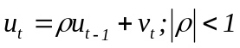
- The random disturbance term follows normal distribution
- The model is not autoregressive, i.e., it does not include lagged value(s) of the dependent variable as independent variable(s)
- There are no missing observations in the data

Durbin-Watson d Statistic
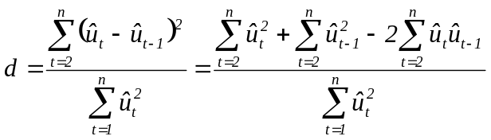
For large sample, 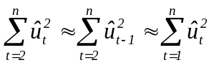
- 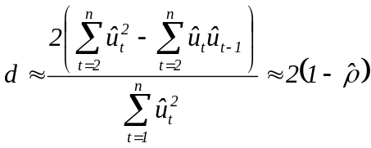
- When 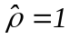(perfect positive autocorrelation), 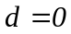;
- When 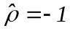(perfect negative autocorrelation), 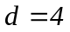
- When 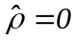(no autocorrelation), 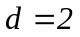
Thus, we have 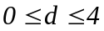
Steps to be followed:
- Estimate the model
- Estimate and compute the ‘d’ statistic
- Compare the computed ‘d’ with the d_{L} (Durbin’s lower limit) and d_{U} (Durbin’s lower limit) for the given number of observations (n), number of explanatory variables (k) and the chosen level of significance
- Null Hypothesis: There is no autocorrelation (i.e., the autocorrelation coefficient is zero)

Decision Rules for the D-W Test:
Decision on Autocorrelation

Positive Indecision No Autocorrelation Indecision Negative
0 dL dU 2 4-dU 4-dL 4
- If 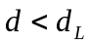, there is positive autocorrelation
- If 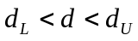, indecision
- If 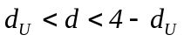, there is no autocorrelation (positive or negative)
- If 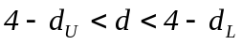, indecision
- If 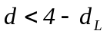, there is negative autocorrelation
Concerns/Limitations:
- The test cannot be applied if the model does not have intercept
- The test cannot be applied if the model is autoregressive
- The test can be applied only for the first-order autoregressive scheme
- The test requires the independent variables to be non-stochastic
- The test result is inconclusive if the computed value of d lies in the indecisive zone

- Durbin-Watson ‘h’ Test for Autocorrelation – For First-order Autoregressive Models
Model: 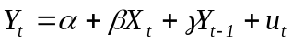
Null Hypothesis: There is no autocorrelation (i.e., the autocorrelation coefficient is zero)
Test Statistic: 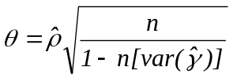(Here, 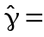Estimated coefficient of lagged dependent variable)
For large sample, 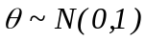(standard normal distribution)
If the null hypothesis is rejected, there is problem of autocorrelation in the estimated model

Steps to be followed:
- Estimate the model
- Estimate and compute the ‘d’ statistic
- Estimate the value of ρ from the computed the ‘d’ statistic
- Estimate 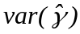 from 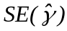
- Compute the test statistic
- Compare the computed value of the test statistic with the tabulated value of z for the given number of observations and at the chosen level of significance
- Rejection of the null hypothesis indicates presence of autocorrelation problem
Concerns/Limitations:
- The denominator of the test statistic 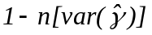may be negative
- The sample size may not be sufficiently large
- The test can be applied only for the first-order autoregressive model

- Breusch-Godfrey Test for Higher Order Autocorrelation
Assumption:
Null Hypothesis: 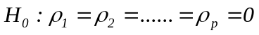(i.e., no autocorrelation of any order)
Steps to be followed
- Estimate the model
- Estimate
- Regress on the lagged (i.e., , 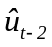,…… , 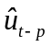 and the original independent variables (with n-p observations):
- For large sample, the test statistic is, 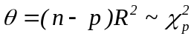
- Rejection of the null hypothesis indicates presence of autocorrelation of some order
Unlike the D-W test, the B-G test can be applied even with autoregressive component in the model

How to distinguish between pure autocorrelation and specification error?

- Resolving the Problem of Autocorrelation
- First-Difference Model: If the autocorrelation coefficient (ρ) is not significantly different from 1 (one)
Assumption: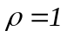 or 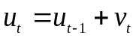(Here, 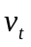satisfies all the usual assumptions of classical linear regression model)
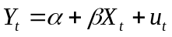 (1)
Lagging (1) for by 1 we get, 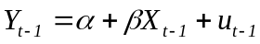 (2)
Subtracting (2) from (1), 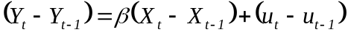
- 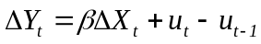 or 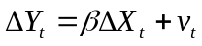 (3)
Steps to be followed:
- Estimate the model
- Estimate and test for autocorrelation
- If there is autocorrelation, test the null hypothesis 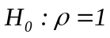
Berenblutt-Webb Test: Test Statistic: 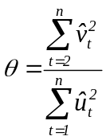 (Here, =residual of model (1) and =residual of model (3))
If 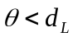with the given number of observations and the number of explanatory variables and at the chosen level of significance, the null hypothesis is not rejected and the first difference model is estimated
- Generate the variables 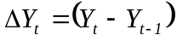 and 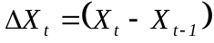
- Estimate the model: with n-1 observations and test for autocorrelation of to confirm that the new model does not have autocorrelation problem
- Issue of Intercept in the first difference model
The model does not have intercept; what should be done?
Model with trend component: 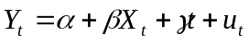 (1)
Lagging (1) for by 1 we get, 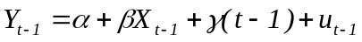 (2)
Subtracting (2) from (1),
- 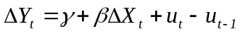 or 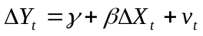 (3)
Thus, inclusion of trend component brings in intercept into the first-difference model. Inclusion of the trend component may also help in resolving/reducing autocorrelation problem.

- Generalized Difference Method: If the autocorrelation coefficient is positive and significantly different from 1 (one)
- Derivation of the new model:
Assumption: 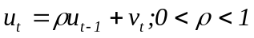(Here, satisfies all the usual assumptions of classical linear regression model)
(1)
Lagging (1) for by 1 and multiplying both the sides by ρ we get
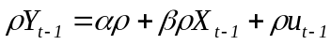 (2)
Subtracting (2) from (1),
(3)

- Steps to be followed:
- Estimate the model
- Estimate and test for autocorrelation
- If there is autocorrelation, get the estimated value of ρ (autocorrelation coefficient) as 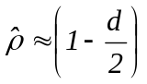 for large sample
- Generate the variables 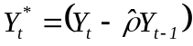 and 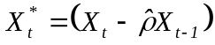
- Estimate the model 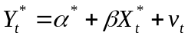 with n-1 observations and test for autocorrelation of to confirm that the new model does not have autocorrelation problem
Can the first-difference or generalized difference model have multicollinearity problem (in case of multiple regression model)?
How to get the best (the most appropriate) estimate of the autocorrelation coefficient (ρ)?
- What to do for the first observation?
Prais-Winsten Transformation:
The following transformation can be used for the first observation: 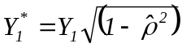 and 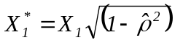
- Estimated value of ρ for small sample:
Theil-Nagar Estimation:
Estimated value of ρ (autocorrelation coefficient) for small sample: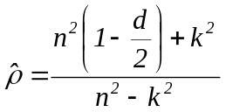
Here, n=number of observations, d=value of the Durbin-Watson statistic, and k=number of coefficients (including the intercept)
Further, 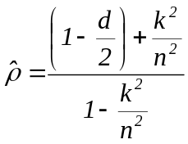
This means that as 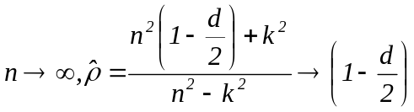
- Alternative estimates of ρ:
- Estimation of the model: 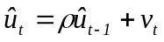and get the estimated value of ρ
Should the above model have an intercept?
How will this regression coefficient be different from the correlation coefficient between and?
- Cochrane-Orcutt interative procedure
Steps to be followed
- Estimate the model 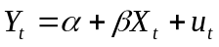
- Use the residuals from the regression to run the regression 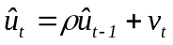 and estimate 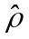
- Estimate the generalized difference equation and re-estimate the coefficients 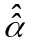and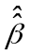
- Estimate the new residuals 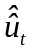using and
- Re-estimate  i.e.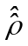using the new residuals
- Estimate generalized difference equation and get new estimates of α and β
- Continue the process until the successive estimates for differ only very marginally (<0.005)

- Hildreth-Lu search procedure
Steps to be followed
- Consider the first-order autoregressive scheme: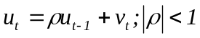
- Select values of ρ between +1 and -1 with an interval of 0.1 (say) and estimate the generalized difference models for each value of ρ
- Obtain the RSS in each case
- Select that value of ρ or the model for which the RSS is minimum
The chosen value of ρ and hence the final estimates of the coefficients may differ depending on the interval taken (say, 0.001 in place of 0.01)
- Estimation of the Model:
Steps to be followed
- Estimate the model
- Estimate the generalized difference model using the coefficient of 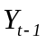as an estimate of ρ
One can also get an estimate of ρ from the coefficient of 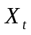and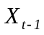- which estimate to use?
The above model is autoregressive – possible endogeneity problem?

